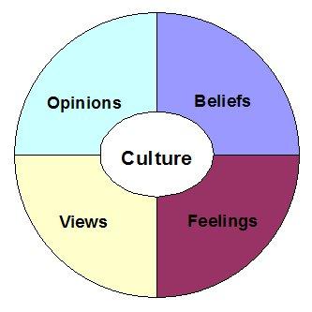
DISCUSS RESEARCH INTO THE INFLUENCE OF CULTURE ON ROMANTIC RELATIONSHIPS (8 + 16 marks)

Relationships in western and non-western cultures differ in many of their views, beliefs and opinions on romantic relationships.
Western cultures reflect individualistic views and ideals. They focus on the interests of the individual and relationships are usually formed out of love and attraction. This was particularly emphasised by Levine who found that people in western cultures expressed a greater reluctance to marry with the absence of love. Individualistic cultures emphasise the idea that relationships can end if the couple becomes unhappy and the culture as a whole is more mobile so people have many chances to meet new potential partners. They stress the importance of voluntary marriages.
Non-western cultures hold the views of collectivist cultures and so the interests of the group are the primary concern. Relationships are usually linked to family ties and economic resources and these relationships tend to be harder to end. Relationships are usually chosen by others and so they agree with the use of arranged marriages.
Arranged marriages, as Batabyal suggested, are based on the idea that a young person is unlikely to choose their lifetime partner well and so “well-wishers” identify potential partners who are then presented to the “agent” who will agree or disagree to the partners’ presented.
There has been several research studies into voluntary and involuntary marriages.
Gupta and Singh studied 100 professional couples in India in which half had love marriages and half arranged. They used liking and love scales over several years and concluded that liking and love was lower at the start of arranged marriages but that it grew over the years to actually exceed that of love marriages. This therefore demonstrated that arranged marriages can be successful. It also shows that maybe well-wishers are indeed in a better position to judge compatibility.
However, there is certain issues with cultural bias and imposed etic as the scales used were devised in the US and so there is problems with the extent to which they can be accurately interpreted in other cultures. This therefore would affect the external validity of their findings and the extent to which it can provide support for arranged marriages.
There has also been conflicting findings by Xioahe and Whyte. They studied women in China and found that those in love marriages were more satisfied. However, China is a rapidly developing culture and therefore the results found may be due to this reason, further highlighting how modern western views emphasise love marriages. The results may also have been due to “acculturation” (internalising the views of another culture). Their study also shows that, perhaps, increased mobility and integration are lessening cultural differences in views on marriage.
However, the problem with their methodology is that they only used women and so there is the issues of gender bias affecting the validity of the results. In addition, the rapid pace of the change in relationships means that research studies such as this one are quickly outdated, further reducing their validity and adding the problem of historical bias.
Nevertheless, there are certain issues regarding the over-simplification of cultures into only two variations. Cultures tend to be more diverse and there is often more variation within cultures than there is between cultures. There is also significant issues with ethics when handling this socially sensitive issue as research can provoke discomfort in participants.
The idea that culture influences on relationships is also quite determinist as it states that our relationships will be determined by the culture we live in. This ignores any idea that humans have the cognitive ability to override our instincts.
Lastly, there is evidence for romantic love being an evolutionary process rather than a result of the culture people have grown up in. A study by Jankowiak found evidence of romantic love in 90% of the 166 societies he studied. This therefore suggests that love and relationships are universal and a product of evolutionary factors and so culture should have little effect.

